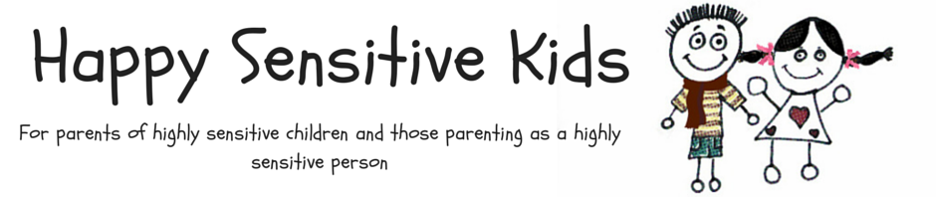
Use these droplets in combination with the printed bucket to visualize how full your bucket could be (or is) today. There are some examples of activities that might be bucket fillers but there are lots of blank droplets for you to fill in yourself once you work out what fills your bucket.

Noisy in class today

Play date

After school activity
A day at school
Screen time
Party!

